# State Transition Diagram

A State Transition Diagram defines a sequence that has a number of states as different functions and actions are performed in the program.

# Symbols used in a State Transition Diagram

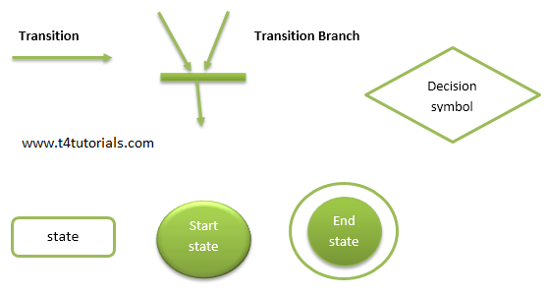

# Example of State Transition Diagram

